Technical Project

Hybrid Exchange + Azure AD Architecture Lab
URL : https://github.com/ukivanlam/On-prem-ADExchange-Hybird-Lab
Description:
Designed and implemented a full Microsoft hybrid messaging environment including:
- Exchange Server 2019 DAG (High Availability)
- Azure AD Connect with Password Hash Sync
- Hybrid Mail Flow & Modern Authentication (HCW)
- DNS split-brain namespace (hk2uk.XXXXX)
- WatchGuard + Firewall NAT + iptable (Trade off ExpressRoute + Firewall)
- P2S VPN (Trade off ExpressRoute)
- SSL Certificate deployment & SMTP Send Connector
- Full IP-based on-prem network design (192.168.10.x)
- Azure VM RODC + AAD Identity Boundary
Skills demonstrated:
Exchange Hybrid • Azure AD • AAD Connect • WatchGuard VPN • DNS • SSL/TLS • SMTP Routing • DAG • Networking • Identity & Access • Cloud Architecture

Diagram:
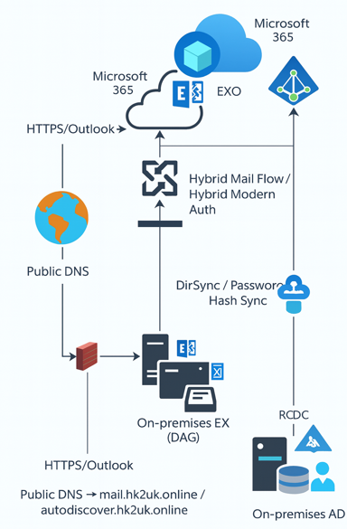

Hybrid Identity & Messaging Integration Validation — Technical Evidence
AD-> Azure ADS | Azure ADS -> AD
Get-ADSyncRule | Select-Object Name,Description,Direction | Get-MgUser -Top 10
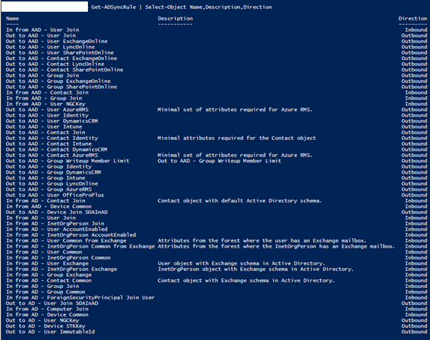 | 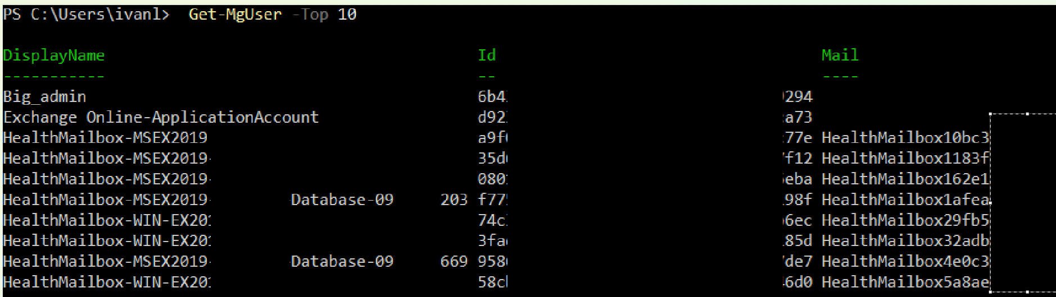
EX - > EX0 | EXO -> EX
Get-OrganizationRelationship | fl *  Get-HybridConfiguration | Get-MigrationEndpoint | fl *
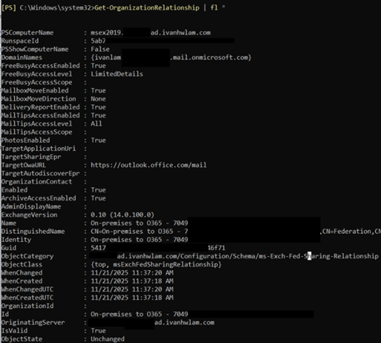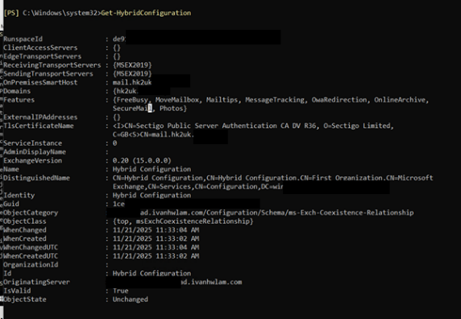 | 